# Release new version

1. Build->Generate signed Bundle / APK

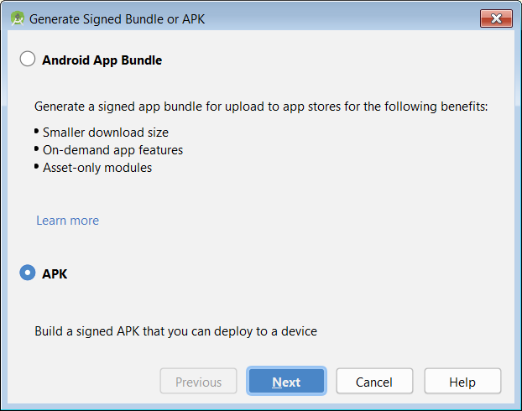

1. Next
2. 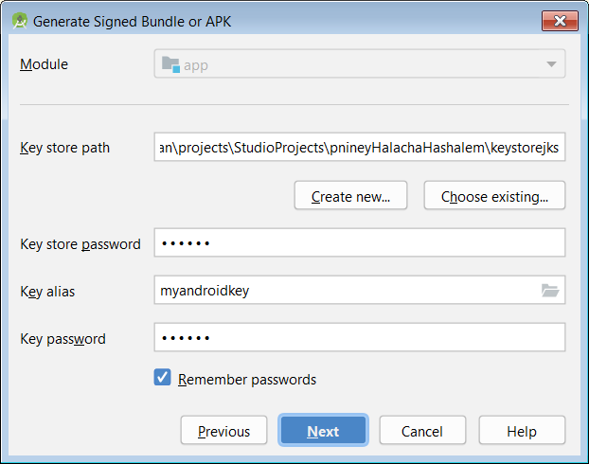
3. Two passwords are: 610028
4. Next
5. 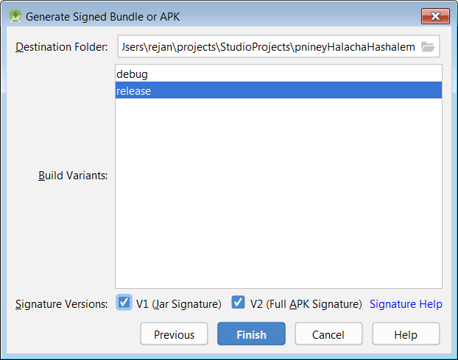
6. Finish
7. The apk location is: \pnineyHalachaHashalem\release\app-release.apk
8. Go to <https://play.google.com/apps/publish>
9. Click on פניני הלכה השלם
10. Release management 🡪 App releases

In this page click on EDIT RELEASE

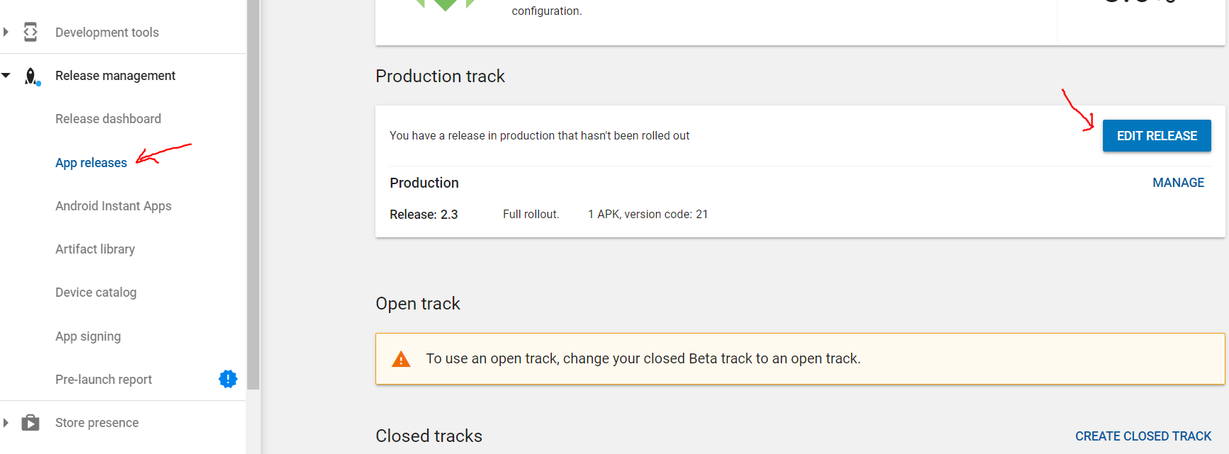

1. Click on  and find your release \pnineyHalachaHashalem\release\app-release.apk. The file will start to upload.

If there is problem like this: ERROR: JAR_SIG_NO_SIGNATURES: No JAR signatures. Try to go in android studio to Buld🡪Clean Project and build the apk file again.

1. Scroll down, and write what’s new in this version in “What's new in this release?” field
2. Click on 
3. Click on 
4. Scroll down in the loaded page and see something like this:

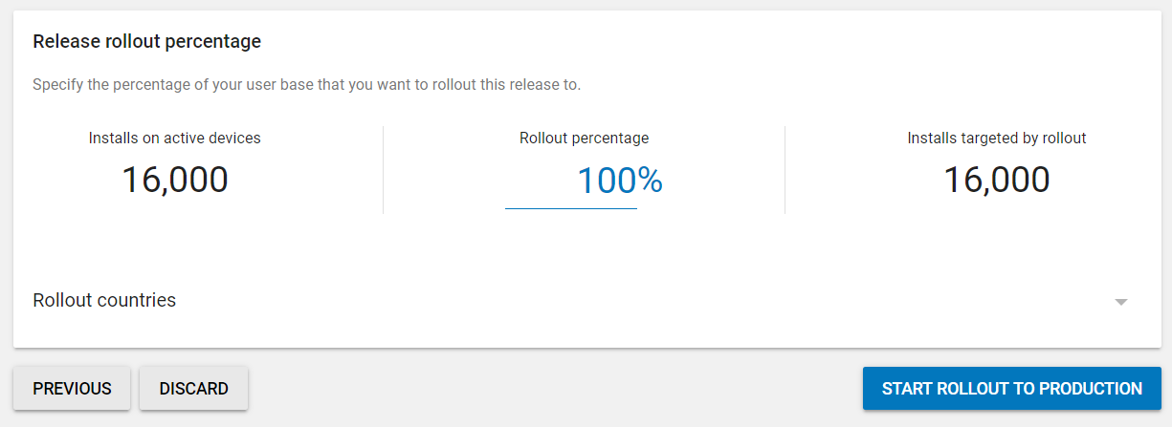

Ensure that it is 100% in the rollout percentage and click on START ROLLOUT TO PRODUCTION

1. In the new page click on 

# Errors and solutions

1. If you get this error: 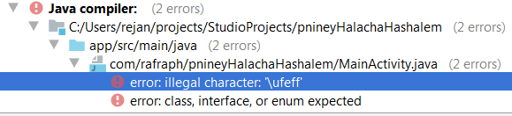

Open the problematic file (in this case MainActivity.java) in notepad++.

Encoding 🡪 Encode in UTF-8

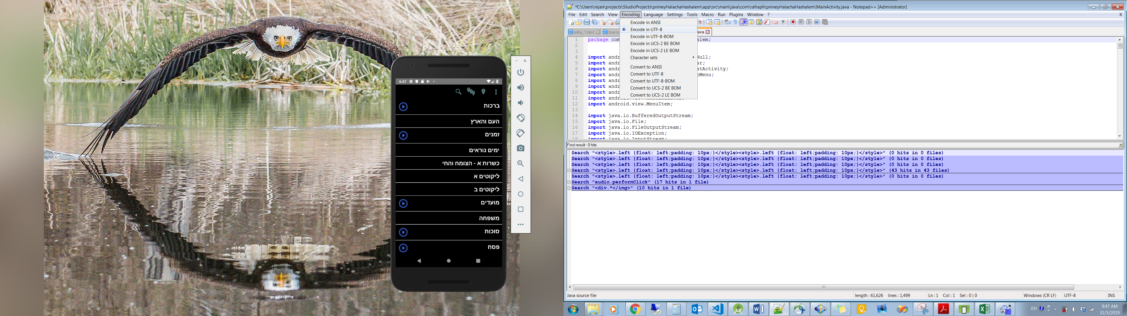

Save the file